|  |  |
| --- | --- |
| **E. Semih Akyuz**  Junior Mechanical Engineering student looking to gain further experience in the Lithography or Aerospace industry. Primary interests include component design, automation, process optimization, and CAD. | 64 Camden Street  Milford, CT 06461  **(475) 689-7127**  **eakyu1@unh.newhaven.edu semihakyuz54@gmail.com**  [**linkedin.com/in/semihakyuz**](https://www.linkedin.com/in/semihakyuz) |

# PROJECT PORTFOLIO

Additional files and documentation can be found at GitHub at the link below.

[E. Semih Akyuz - Portfolio](https://github.com/ESemihAkyuz/ESemihAkyuz.github.io)

# WORK PROJECTS

**From Design To Fabrication** — *Display Piece Showcasing Gathered Skills Throughout ASML Internship*

Takeaways:

- Understanding Relationships Between Design and Manufacturability

- Process Planning

- 3D Modeling

- Dimensioning and Tolerancing

- G-Code generation (Mastercam Programming)

- Complex Machine Setups & Fixturing

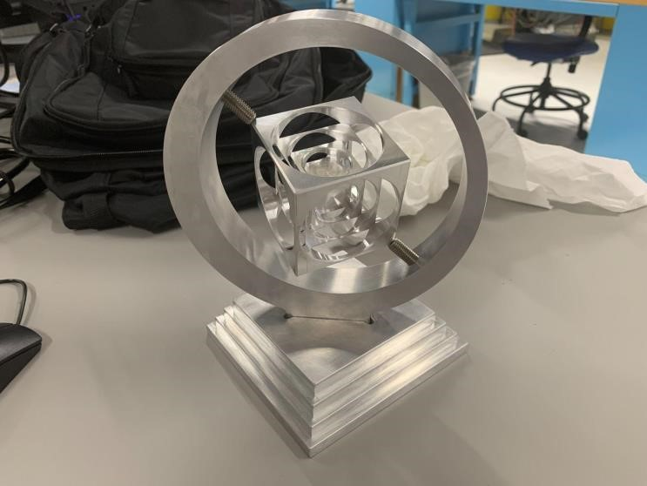Product Image

[Process Images at GitHub](https://github.com/ESemihAkyuz/ESemihAkyuz.github.io/tree/b0e738f55b8e32d2538ec818424b3014642f0158/Work%20Projects/SpinningCubeImages)

**Work Request System Overhaul for ASML Model Shop**

**Workflow Overhaul**  
- Identified inefficiencies in the team's workflow.  
- Redesigned & streamlined processes for efficiency and customer transparency.  
- Added automated internal and external feedback loops.  
- Automated data modification & approval processes.

- Created easy to use interfaces for management and customers.  
- Drafted a site-wide communication in the newsletter informing customers.

- Presented the changes to the D&E DM.  
- Saving upwards of $140,000/year in work hours for the Model Shop team.

**Continued on Next Page**

**Internal Changes**

- Reduced platforms used from 4 to 2.

- Reduced instances of manual typing from 15-20 to 3.

- Simplified escalation process to 2 clicks instead of a multi-participant email chain.

- Removed the need for manual file sharing involved in multiple parts of the order.

- Removed the need for 1 to 2 manual emails depending on the order.

- Reduced needed meeting discussion time for each order by 2-3 minutes.

- Removed the need to manually update the team planner.

- Constrained sub-processes to their own platforms.

- Removed the need to discuss order timing with each customer.

- Added a variable control panel for management that allows instant modification of Outgoing automated message formats, included info, and automation logic with no understanding of the underlying code.

**External / Customer Experience Changes**

- Removed reliance on the Model Shop team availability for order updates/changes.

- Removed the need for manual file sharing.

- Created Teams integration to show current backlog and escalation requirements.

- Added 3 auto-verification emails for various events.

- Added automatic file uploads.

- Reduced escalation process to 2 clicks.

- Streamlined the request forms to improve efficiency and clarity.

BEFORE

AFTER

# UNIVERSITY PROJECTS

**Push & Go Cereal Dispenser** — *Automated Cereal & Bowl Dispenser for Cafeterias & Dining Halls*

Created a product that fulfills a market need.

- Experienced Various Phases of Product Design

- Component Selection & Research

- Arduino (C++) Programming

- Component Design

- 3D Modeling & Tolerancing

- Mechanical Assembly Design

- Process Planning

- 3D Printing

- Circuitry and Electrical Components

Deliverable Images:

Project Presentation Can be Found at [GitHub](https://github.com/ESemihAkyuz/ESemihAkyuz.github.io/tree/b0e738f55b8e32d2538ec818424b3014642f0158/School%20Projects/Push%26Go%20Cereal%20Dispenser)

**Internal Stress Automated Spreadsheet** — *Calculating the Internal Stresses of a Traffic Light Support Structure (Mechanics of Materials)*

Created an Automated & Modifiable Excel Spreadsheet That Returns the Following:

- Center of Gravity & Centroid Calculations

- Second Moment of Inertia Calculations

- Principal Stresses & Plane Calculations

- Shear Stresses & Shear Plane Calculations

- Modifiable Forces, Wind Speed, Dimensions, Safety Factor etc.

Please View Spreadsheet & PDF Version At [GitHub](https://github.com/ESemihAkyuz/ESemihAkyuz.github.io/tree/b0e738f55b8e32d2538ec818424b3014642f0158/School%20Projects/Internal%20Stresses%20of%20A%20Traffic%20Light%20Structure)

**Technical Memorandums –** *Technical Writing for Instrumentation Lab*

- Cutoff Freq of LM741 Through Base & Amplified Sine Waves

- Flywheel Displacement Through Varying Rotational Frequencies

- Load Cell & Strain Gage Evaluation for Proposed Measurement System

- Temperature Readings of a Thermistor & Amplified Thermocouple

- Type K1 & K2 Pressure Transducer Calibration

Memo PDF’s At [GitHub](https://github.com/ESemihAkyuz/ESemihAkyuz.github.io/tree/b0e738f55b8e32d2538ec818424b3014642f0158/School%20Projects/Instrumentation%20Laboratory%20-%20Technical%20Memos)

# HOBBY PROJECTS

**Mohr’s Circle Generator** — *C++ Application*

User Inputs of Shear and Axial Stresses are Used to Generate a Graphical Output Which Represents Principal Stresses and Planes.

- Pack & Go Executable Application with No Installer or Dependencies

